**Phase 1 Practice Project – Assisted Practice**

**7 . Writing a program in java to create, read, update, and delete operations on the files in java.**

**Create:**

**Source Code:**

**package** FileOperations;

**import** java.io.*;

**public** **class** Book {

**public** **static** **void** main(String[] args) {

// create a file object for the current location

File file = **new** File("SampleFile.txt");

**try** {

// trying to create a file based on the object

**boolean** value = file.createNewFile();

**if** (value) {

System.***out***.println("The new file is created.");

}

**else** {

System.***out***.println("The file already exists.");

}

}

**catch**(Exception e) {

e.getStackTrace();

}

}

}

**Output:**

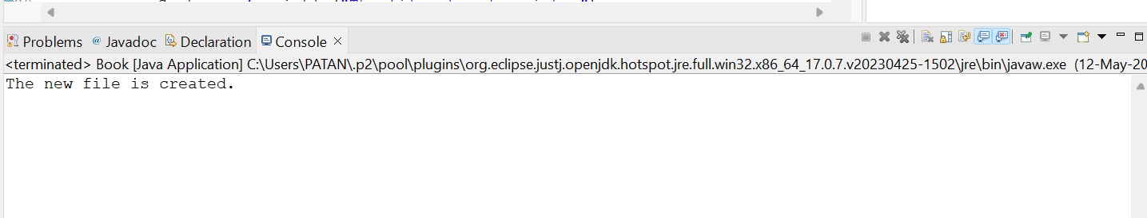

**Read**

**Source Code:**

package com.FileOperations;

import java.io.File;

import java.io.FileInputStream;

import java.io.IOException;

import java.util.*;

import java.io.FileReader;

public class FileReaders {

public static void main(String[] args) throws IOException {

File file = new File("./Text.txt");

if(!file.exists())

file.createNewFile();

FileReader fr = new FileReader(file);

int asciiCode;

String text = new String();

while((asciiCode=fr.read())!= -1) {

text += String.valueOf((char)asciiCode);

//System.out.println((char)asciiCode);

}

System.out.println();

System.out.println(text);

fr.close();

}

}

**Output:**

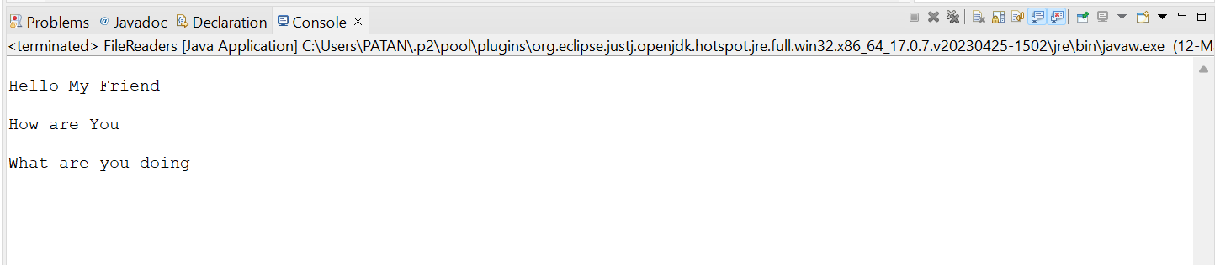

**Update:**

**Source Code:**

**package** FileOperations;

**import** java.io.FileWriter;

**public** **class** BookWriter {

**public** **static** **void** main(String args[]) {

String data = "This is the data in the output file";

**try** {

// Creates a Writer using FileWriter

FileWriter output = **new** FileWriter("output.txt");

// Writes string to the file

output.write(data);

System.***out***.println("Data is written to the file.");

// Closes the writer

output.close();

}

**catch** (Exception e) {

e.getStackTrace();

}

}

}

**Output:**

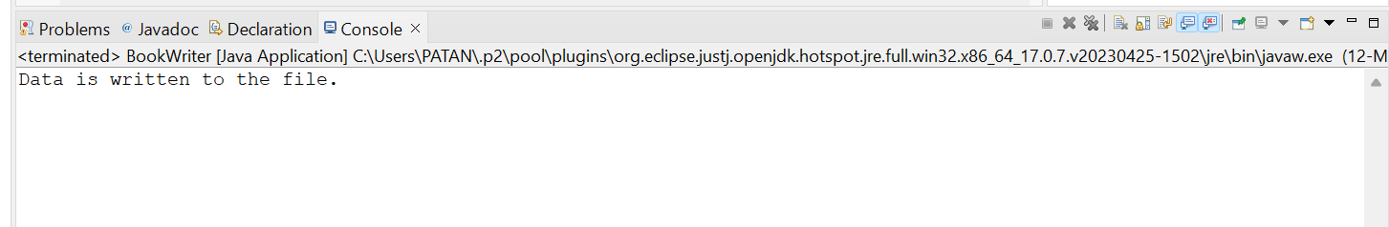

**Delete:**

**Source Code:**

**package** FileOperations;

**import** java.io.File;

**public** **class** BookDelete {

**public** **static** **void** main(String[] args) {

// creates a file object

File file = **new** File("file.txt");

// deletes the file

**boolean** value = file.delete();

**if**(value) {

System.***out***.println("The File is deleted.");

}

**else** {

System.***out***.println("The File is not deleted.");

}

}

}

**Output:**

